**TASK1)**

-- **database creation**

CREATE DATABASE SISDB;

USE SISDB;

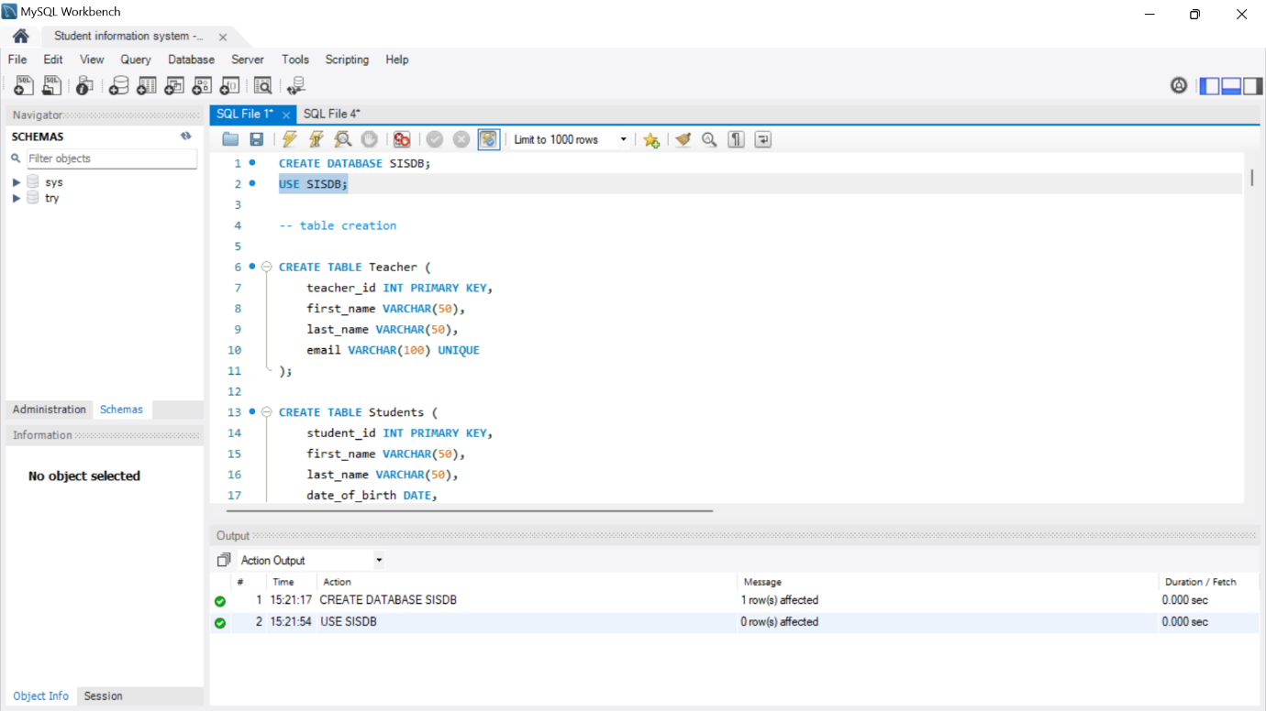

**-- table creation**

CREATE TABLE Teacher (

teacher_id INT PRIMARY KEY,

first_name VARCHAR(50),

last_name VARCHAR(50),

email VARCHAR(100) UNIQUE

);

CREATE TABLE Students (

student_id INT PRIMARY KEY,

first_name VARCHAR(50),

last_name VARCHAR(50),

date_of_birth DATE,

email VARCHAR(100) UNIQUE,

phone_number VARCHAR(20)

);

CREATE TABLE Courses (

course_id INT PRIMARY KEY,

course_name VARCHAR(100),

credits INT,

teacher_id INT,

FOREIGN KEY (teacher_id) REFERENCES Teacher(teacher_id)

);

CREATE TABLE Enrollments (

enrollment_id INT PRIMARY KEY ,

student_id INT,

course_id INT,

enrollment_date DATE,

FOREIGN KEY (student_id) REFERENCES Students(student_id),

FOREIGN KEY (course_id) REFERENCES Courses(course_id)

);

CREATE TABLE Payments (

payment_id INT PRIMARY KEY,

student_id INT,

amount DECIMAL(10, 2),

payment_date DATE,

FOREIGN KEY (student_id) REFERENCES Students(student_id)

);

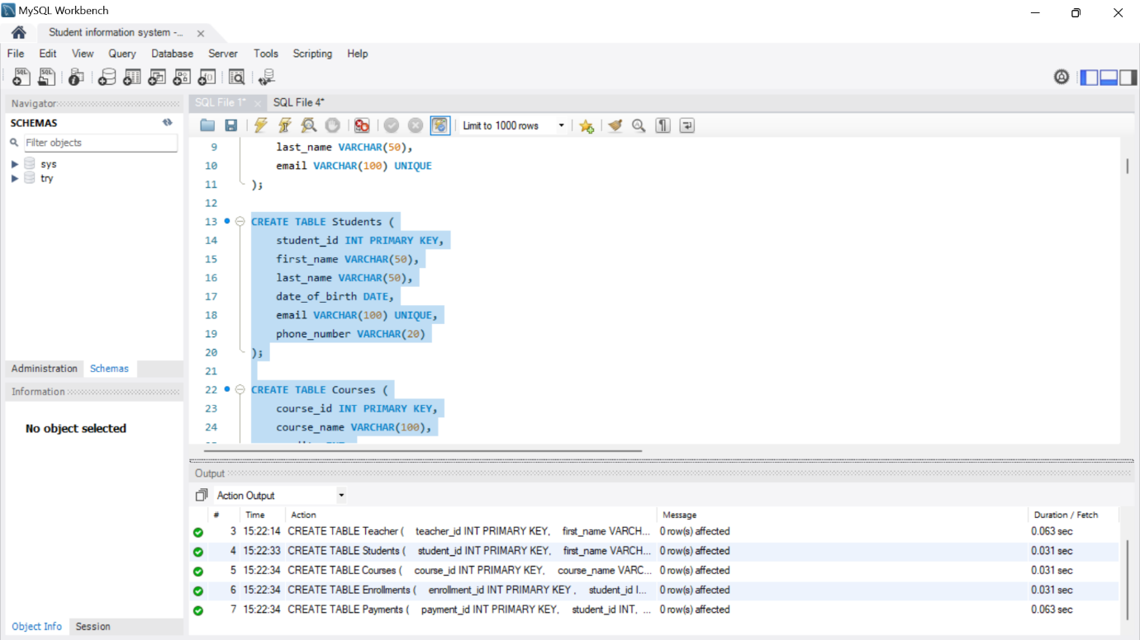

**NORMALIZATION-**

/*

the first three normal forms (1NF, 2NF, 3NF).

1. Students Table:

1NF:

The table is in 1NF as it contains only atomic values in each cell.

2NF:

The table is in 2NF since it has a single-column primary key, and there are no partial dependencies.

3NF:

The table is in 3NF. All attributes are functionally dependent on the primary key (student_id).

2. Courses Table:

1NF:

The table is in 1NF as it contains only atomic values in each cell.

2NF:

The table is in 2NF since it has a single-column primary key, and there are no partial dependencies.

3NF:

The table is in 3NF. All non-prime attributes are functionally dependent on the primary key (course_id).

3. Enrollments Table:

1NF:

The table is in 1NF as it contains only atomic values in each cell.

2NF:

The table is in 2NF since it has a single-column primary key, and there are no partial dependencies.

3NF:

The table is in 3NF. All non-prime attributes are functionally dependent on the primary key (enrollment_id).

4. Teacher Table:

1NF:

The table is in 1NF as it contains only atomic values in each cell.

2NF:

The table is in 2NF since it has a single-column primary key, and there are no partial dependencies.

3NF:

The table is in 3NF. All attributes are functionally dependent on the primary key (teacher_id).

5. Payments Table:

1NF:

The table is in 1NF as it contains only atomic values in each cell.

2NF:

The table is in 2NF since it has a single-column primary key, and there are no partial dependencies.

3NF:

The table is in 3NF. All non-prime attributes are functionally dependent on the primary key (payment_id).

all tables have atomic values, no partial dependencies on the primary key, and no transitive dependencies.

*/

**ER DIAGRAM**

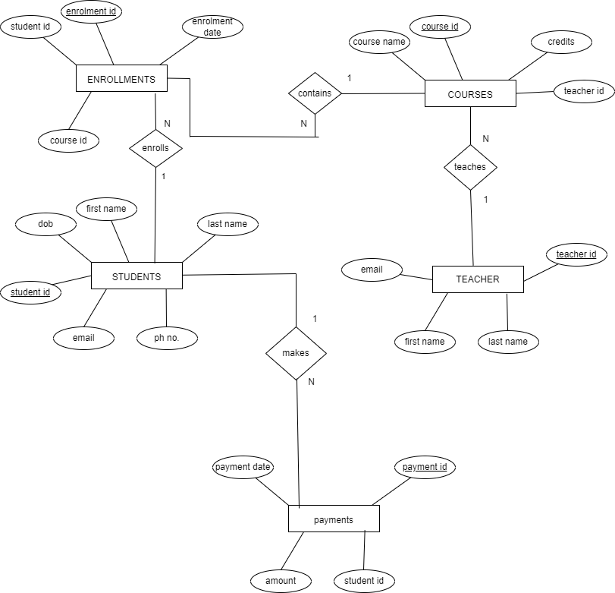

**TASK2)**

**-- values insertion**

INSERT INTO Students (student_id, first_name, last_name, date_of_birth, email, phone_number)

VALUES

(301, 'Aarav', 'Kumar', '1995-03-20', 'aarav.kumar@example.com', '9876543210'),

(302, 'Isha', 'Singh', '1998-07-12', 'isha.singh@example.com', '8765432109'),

(303, 'Arjun', 'Sharma', '1997-05-15', 'arjun.sharma@example.com', '7654321098'),

(304, 'Anaya', 'Patel', '1996-12-02', 'anaya.patel@example.com', '6543210987'),

(305, 'Rohan', 'Verma', '1999-08-25', 'rohan.verma@example.com', '5432109876'),

(306, 'Neha', 'Gupta', '1994-10-08', 'neha.gupta@example.com', '4321098765'),

(307, 'Vivan', 'Rajput', '1993-06-30', 'vivan.rajput@example.com', '3210987654'),

(308, 'Avani', 'Reddy', '1992-04-12', 'avani.reddy@example.com', '2109876543'),

(309, 'Aryan', 'Malhotra', '1991-02-18', 'aryan.malhotra@example.com', '1098765432'),

(310, 'Sanya', 'Thakur', '1990-11-05', 'sanya.thakur@example.com', '9876543210'),

(311, 'Aisha', 'Malik', '1994-09-18', 'aisha.malik@example.com', '9876543210'),

(312, 'Rahul', 'Sharma', '1996-05-12', 'rahul.sharma@example.com', '8765432109'),

(313, 'Sara', 'Khan', '1998-03-25', 'sara.khan@example.com', '7654321098'),

(314, 'Aditya', 'Verma', '1997-11-02', 'aditya.verma@example.com', '6543210987'),

(315, 'Neha', 'Singh', '1995-08-25', 'neha.singh@example.com', '5432109876');

INSERT INTO Teacher (teacher_id, first_name, last_name, email)

VALUES

(101, 'Professor', 'Brown', 'prof.brown@example.com'),

(102, 'Dr.', 'Taylor', 'dr.taylor@example.com'),

(103, 'Ms.', 'Clark', 'ms.clark@example.com'),

(104, 'Mr.', 'Lee', 'mr.lee@example.com'),

(105, 'Mrs.', 'Adams', 'mrs.adams@example.com'),

(106, 'Dr.', 'Garcia', 'dr.garcia@example.com'),

(107, 'Mrs.', 'Martin', 'mrs.martin@example.com'),

(108, 'Mr.', 'Roberts', 'mr.roberts@example.com'),

(109, 'Professor', 'Wang', 'prof.wang@example.com'),

(110, 'Dr.', 'Lopez', 'dr.lopez@example.com'),

(111, 'Prof.', 'Smith', 'prof.smith@example.com'),

(312, 'Dr.', 'Anderson', 'dr.anderson@example.com'),

(313, 'Ms.', 'Johnson', 'ms.johnson@example.com');

INSERT INTO Courses (course_id, course_name, credits, teacher_id)

VALUES

(401, 'Physics', 4, 101),

(402, 'Art', 3, 102),

(403, 'Mathematics', 3, 103),

(404, 'Literature', 4, 104),

(405, 'History', 3, 105),

(406, 'Computer Science', 4, 106),

(407, 'Biology', 4, 107),

(408, 'Chemistry', 3, 108),

(409, 'Geography', 3, 109),

(410, 'Economics', 4, 110),

(411, 'Psychology', 3, 101),

(412, 'Sociology', 3, 102),

(413, 'Philosophy', 4, 103),

(414, 'Statistics', 3, 104),

(415, 'Political Science', 4, 105),

(421, 'Psychology', 3, 101),

(422, 'Sociology', 3, 102),

(423, 'Philosophy', 4, 103),

(424, 'Statistics', 3, 104),

(425, 'Political Science', 4, 105);

INSERT INTO Enrollments (enrollment_id, student_id, course_id, enrollment_date)

VALUES

(501, 301, 401, '2023-01-05'),

(502, 301, 402, '2023-02-10'),

(503, 302, 410, '2023-01-15'),

(504, 303, 403, '2023-03-01'),

(505, 304, 404, '2023-02-20'),

(506, 305, 405, '2023-01-10'),

(507, 306, 406, '2023-01-05'),

(508, 307, 407, '2023-02-15'),

(509, 308, 408, '2023-02-25'),

(510, 309, 409, '2023-03-05'),

(521, 311, 411, '2023-03-15'),

(522, 311, 412, '2023-03-20'),

(523, 312, 413, '2023-04-01'),

(524, 312, 414, '2023-04-10'),

(525, 313, 415, '2023-04-15'),

(526, 313, 401, '2023-05-01'),

(527, 314, 402, '2023-05-10'),

(528, 314, 403, '2023-05-20'),

(529, 315, 404, '2023-06-01'),

(530, 315, 405, '2023-06-10'),

(531, 302, 406, '2023-06-20'),

(532, 302, 407, '2023-07-05'),

(533, 303, 408, '2023-07-15'),

(534, 304, 409, '2023-08-01'),

(535, 305, 410, '2023-08-10');

INSERT INTO Payments (payment_id, student_id, amount, payment_date)

VALUES

(601, 301, 80.00, '2023-01-10'),

(602, 302, 60.50, '2023-02-15'),

(603, 303, 90.00, '2023-03-01'),

(604, 304, 75.00, '2023-02-20'),

(605, 305, 100.00, '2023-01-15'),

(606, 306, 120.00, '2023-03-05'),

(607, 307, 95.50, '2023-02-10'),

(608, 308, 85.00, '2023-01-20'),

(609, 309, 110.00, '2023-02-25'),

(610, 310, 70.00, '2023-01-05');

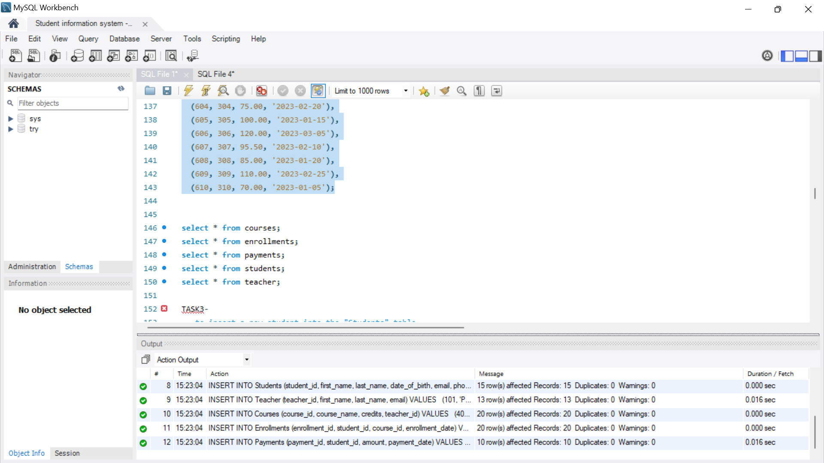

**TASK3-**

**-- to insert a new student into the "Students" table**

INSERT INTO Students (student_id,first_name, last_name, date_of_birth, email, phone_number)

VALUES (20,'HAPPY', 'CAT', '2000-08-15', 'us@gmail.com', '1234567890');

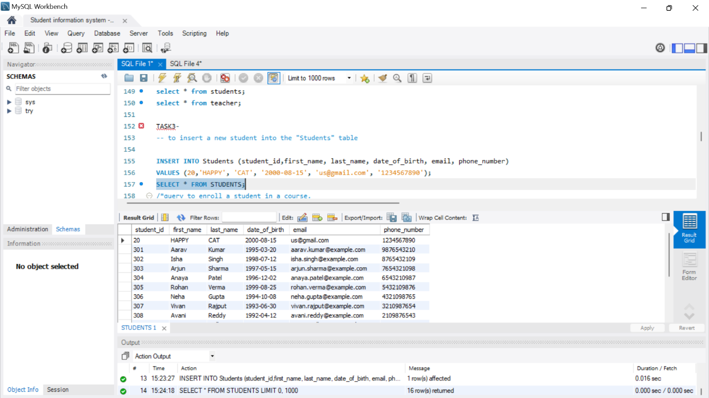

**/*query to enroll a student in a course.**

**Choose an existing student and course and insert a record into the "Enrollments" table with the enrollment date*/**

select * from enrollments;

INSERT INTO Enrollments (enrollment_id, student_id, course_id, enrollment_date)

VALUES (12, 301, 401, '2023-12-01');

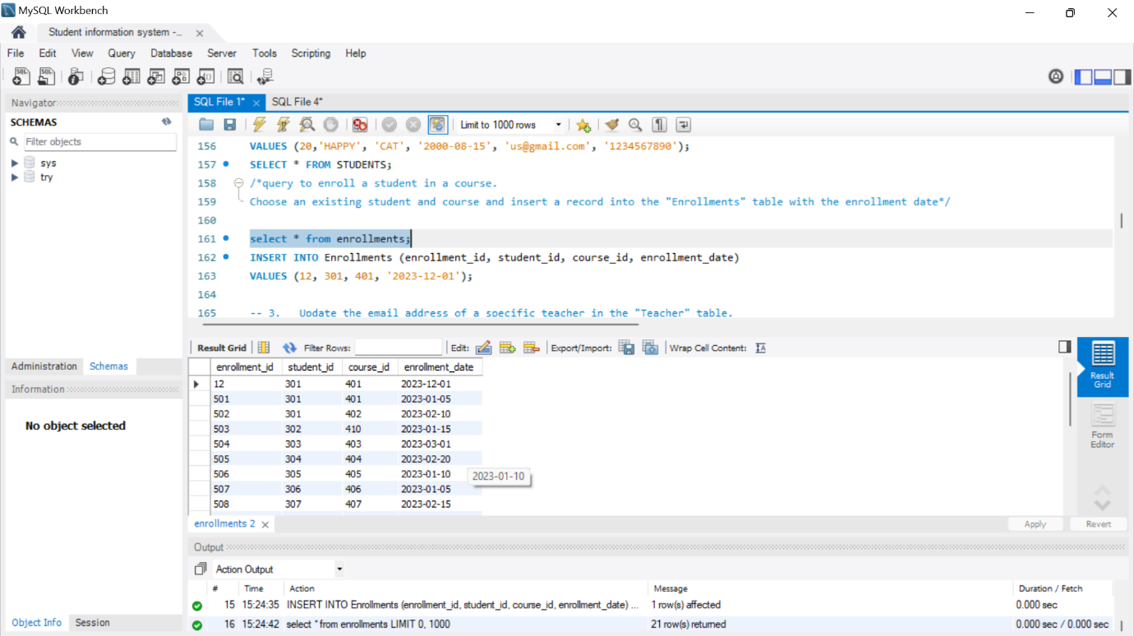

**-- 3. Update the email address of a specific teacher in the "Teacher" table.**

UPDATE Teacher SET email = 'mew@gmailcom' WHERE teacher_id = 107;

select * from teacher;

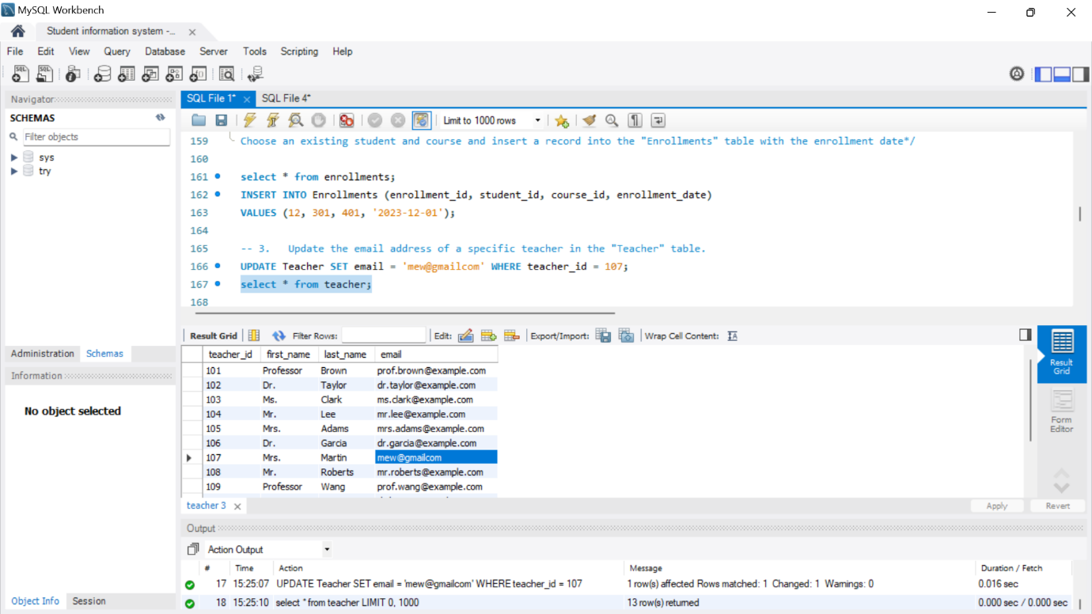

**-- query to delete a specific enrollment record from the "Enrollments" table**

DELETE FROM Enrollments

WHERE student_id = 301 AND course_id = 401;

select * from enrollments;

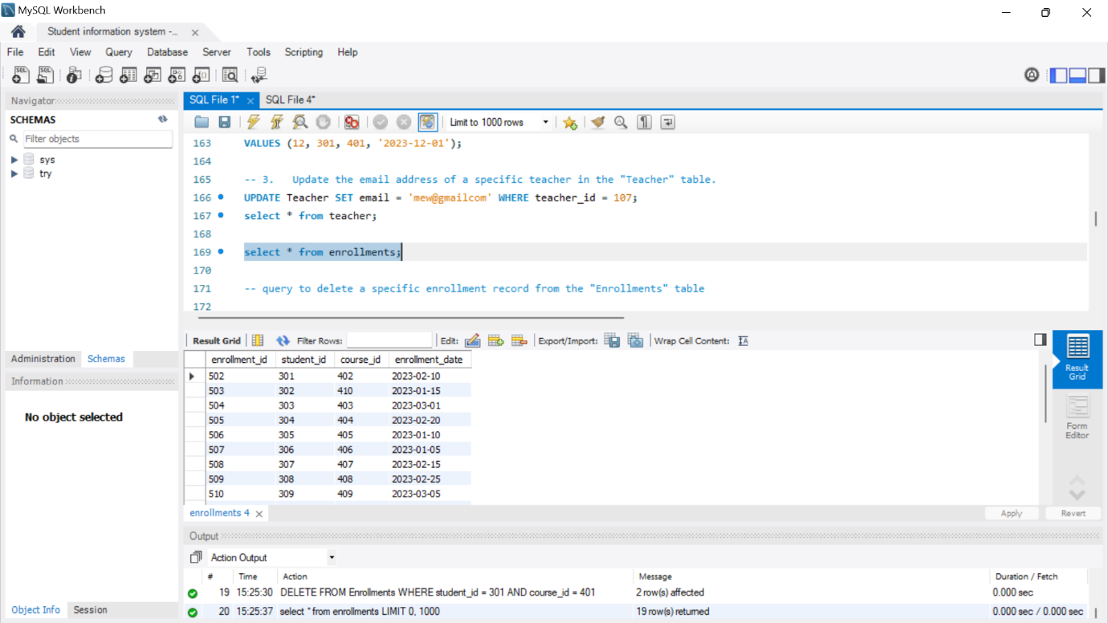

**-- Update the "Courses" table to assign a specific teacher to a course.**

select * from courses;

UPDATE Courses

SET teacher_id = 101

WHERE course_id = 402; 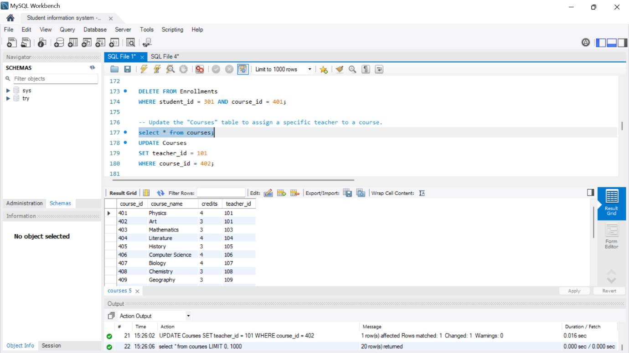

**-- Delete a specific student from the "Students" table and remove all their enrollment records from the "Enrollments" table**

DELETE FROM Payments WHERE student_id = 301;

DELETE FROM Enrollments WHERE student_id = 301;

DELETE FROM Students WHERE student_id = 301;

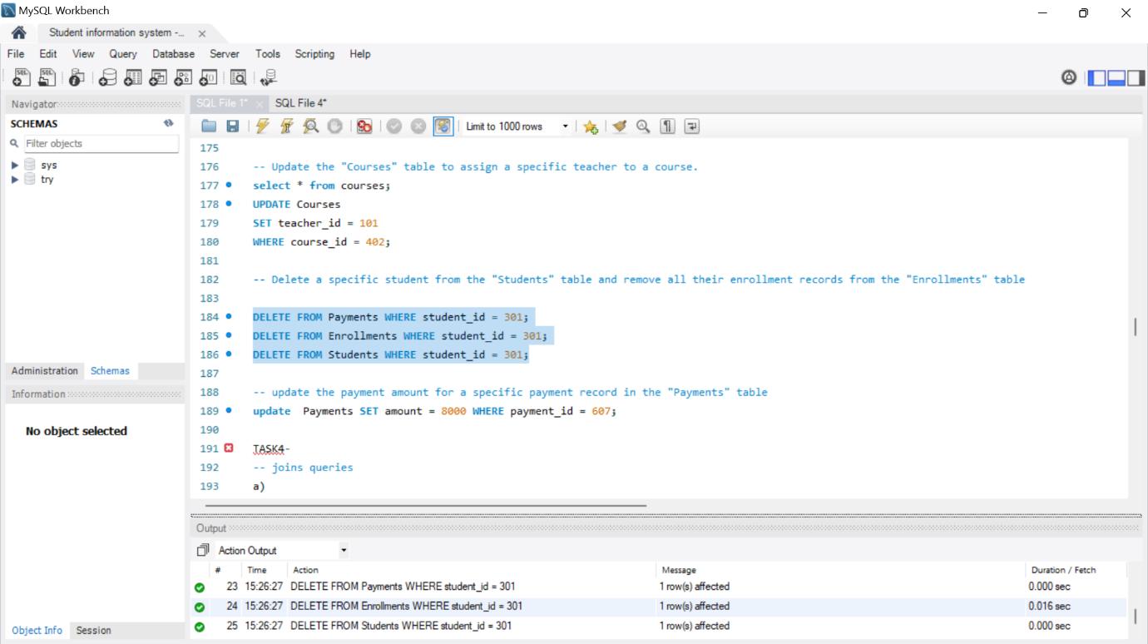

**-- update the payment amount for a specific payment record in the "Payments" table**

update Payments SET amount = 8000 WHERE payment_id = 607;

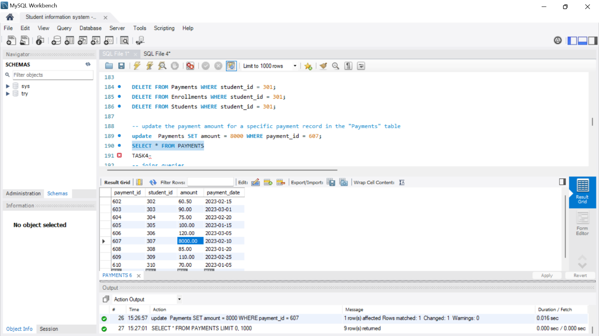

**TASK4-**

-- joins queries

**1. Write an SQL query to calculate the total payments made by a specific student. You will need to join the "Payments" table with the "Students" table based on the student's ID.**

SELECT s.student_id, s.first_name, s.last_name, SUM(p.amount) AS total_payments

FROM Students s

JOIN Payments p ON s.student_id = p.student_id

WHERE s.student_id = 302

GROUP BY s.student_id, s.first_name, s.last_name;

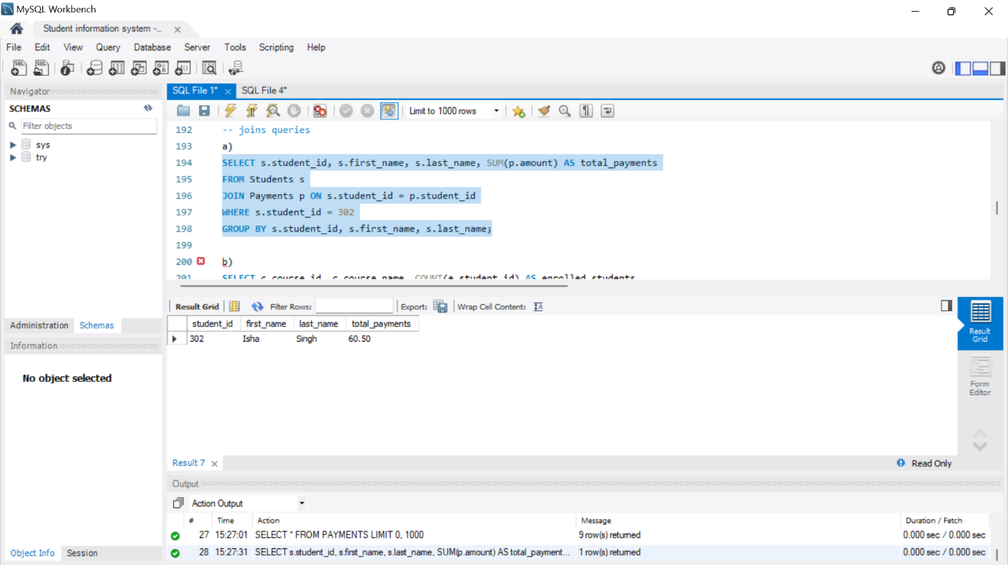

**2. Write an SQL query to retrieve a list of courses along with the count of students enrolled in each course. Use a JOIN operation between the "Courses" table and the "Enrollments" table.**

SELECT c.course_id, c.course_name, COUNT(e.student_id) AS enrolled_students

FROM Courses c

LEFT JOIN Enrollments e ON c.course_id = e.course_id

GROUP BY c.course_id, c.course_name;

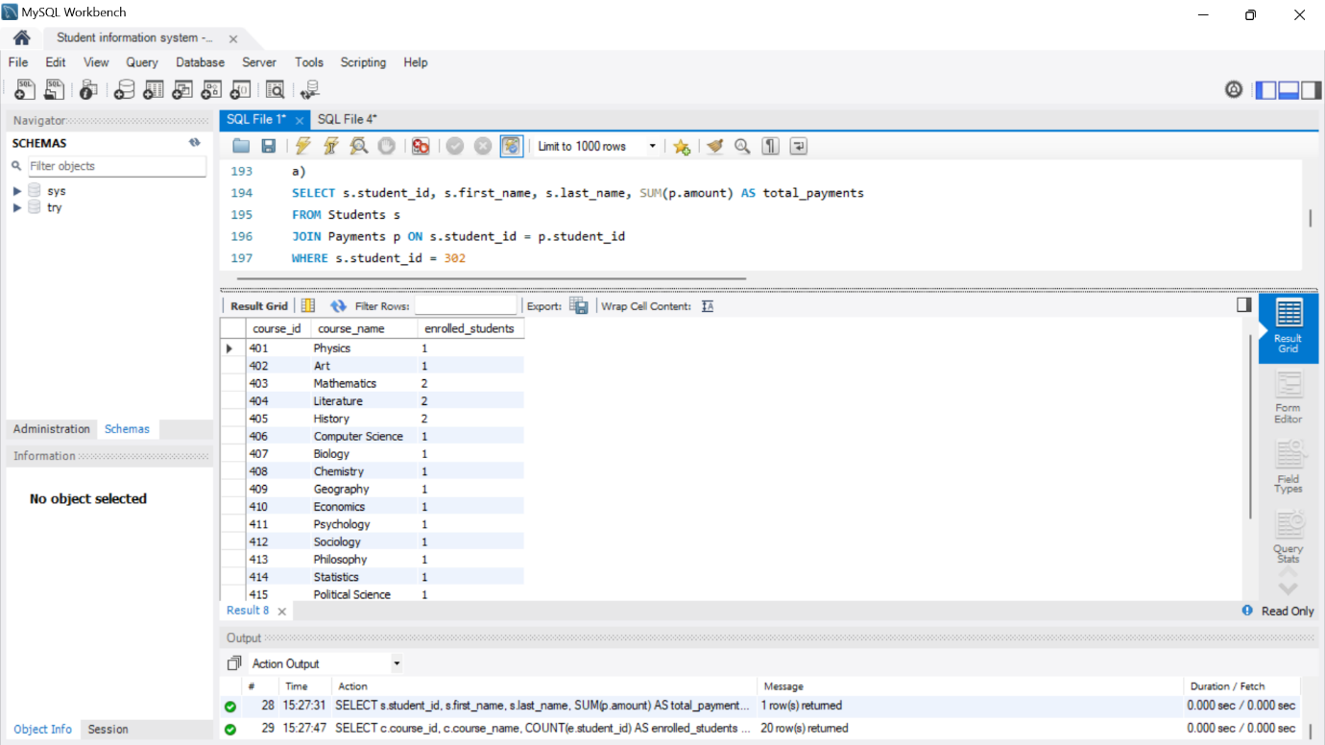

**3. Write an SQL query to find the names of students who have not enrolled in any course. Use a LEFT JOIN between the "Students" table and the "Enrollments" table to identify students without enrollments.**

SELECT s.first_name, s.last_name

FROM Students s

LEFT JOIN Enrollments e ON s.student_id = e.student_id

WHERE e.student_id IS NULL;

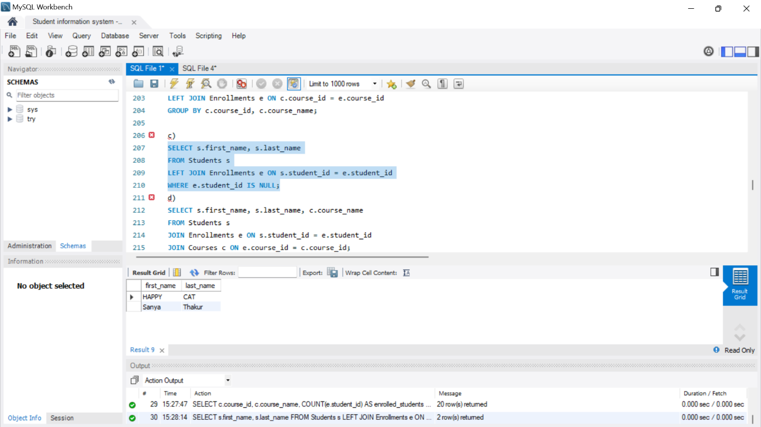

**4. Write an SQL query to retrieve the first name, last name of students, and the names of the courses they are enrolled in. Use JOIN operations between the "Students" table and the "Enrollments" and "Courses" tables.**

SELECT s.first_name, s.last_name, c.course_name

FROM Students s

JOIN Enrollments e ON s.student_id = e.student_id

JOIN Courses c ON e.course_id = c.course_id;

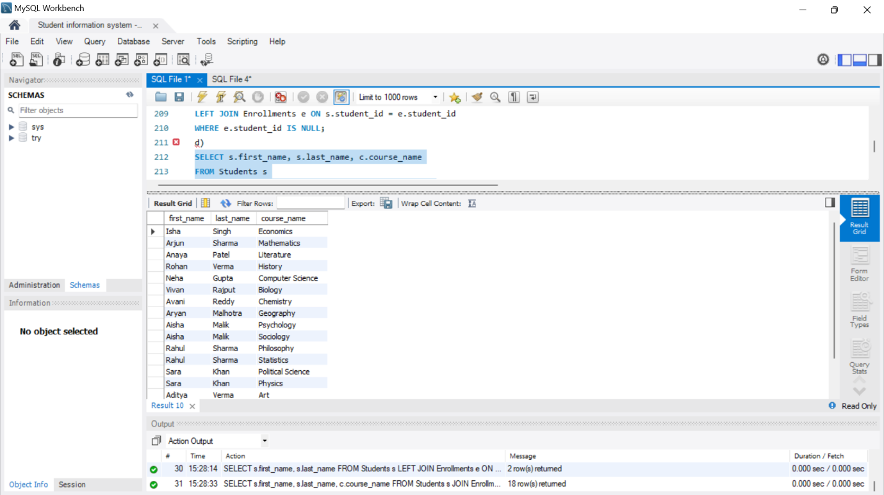

**5. Create a query to list the names of teachers and the courses they are assigned to. Join the "Teacher" table with the "Courses" table.**

SELECT t.first_name, t.last_name, c.course_name

FROM Teacher t

JOIN Courses c ON t.teacher_id = c.teacher_id;

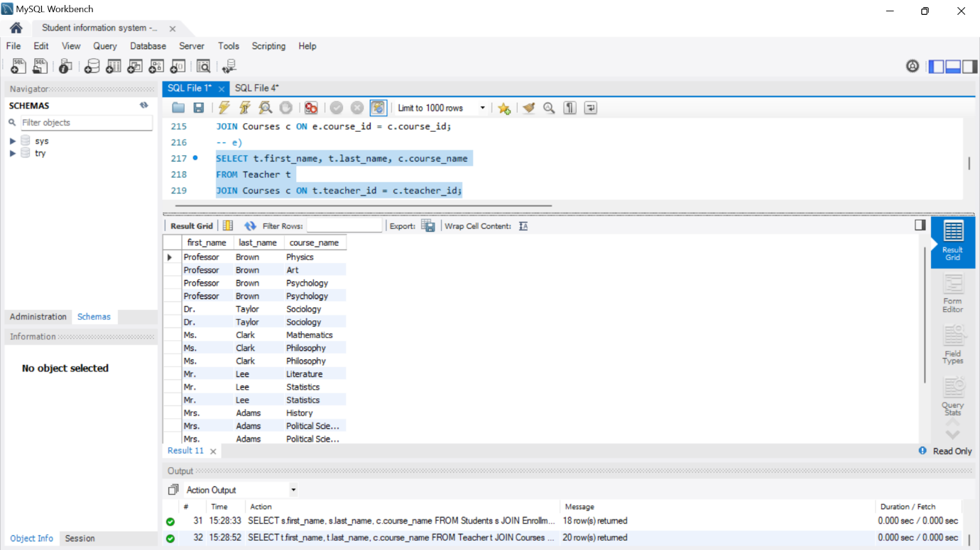

**6. Retrieve a list of students and their enrollment dates for a specific course. You'll need to join the "Students" table with the "Enrollments" and "Courses" tables..**

SELECT s.first_name, s.last_name, e.enrollment_date

FROM Students s

JOIN Enrollments e ON s.student_id = e.student_id

WHERE e.course_id = 403;

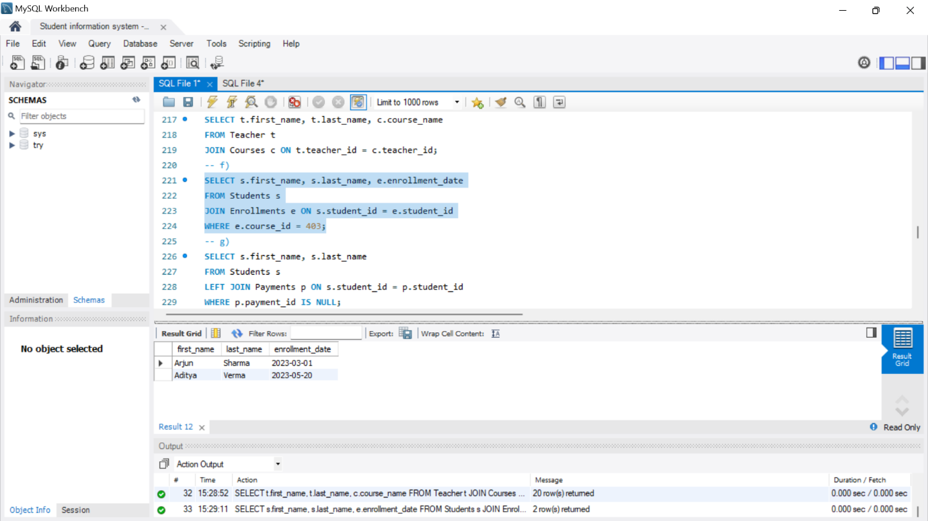

**7. Find the names of students who have not made any payments. Use a LEFT JOIN between the "Students" table and the "Payments" table and filter for students with NULL payment records.**

SELECT s.first_name, s.last_name

FROM Students s

LEFT JOIN Payments p ON s.student_id = p.student_id

WHERE p.payment_id IS NULL;

-- Insert additional values into Courses table

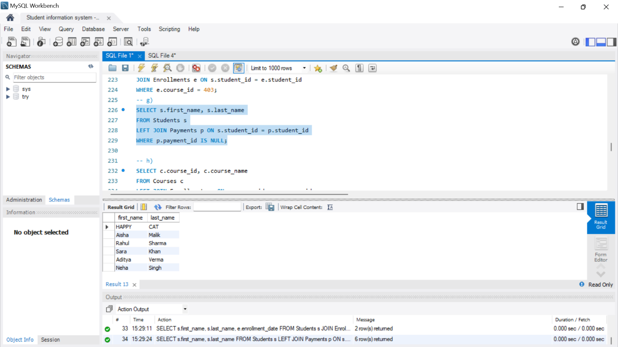

**8. Write a query to identify courses that have no enrollments. You'll need to use a LEFT JOIN between the "Courses" table and the "Enrollments" table and filter for courses with NULL enrollment records.**

SELECT c.course_id, c.course_name

FROM Courses c

LEFT JOIN Enrollments e ON c.course_id = e.course_id

WHERE e.enrollment_id IS NULL;

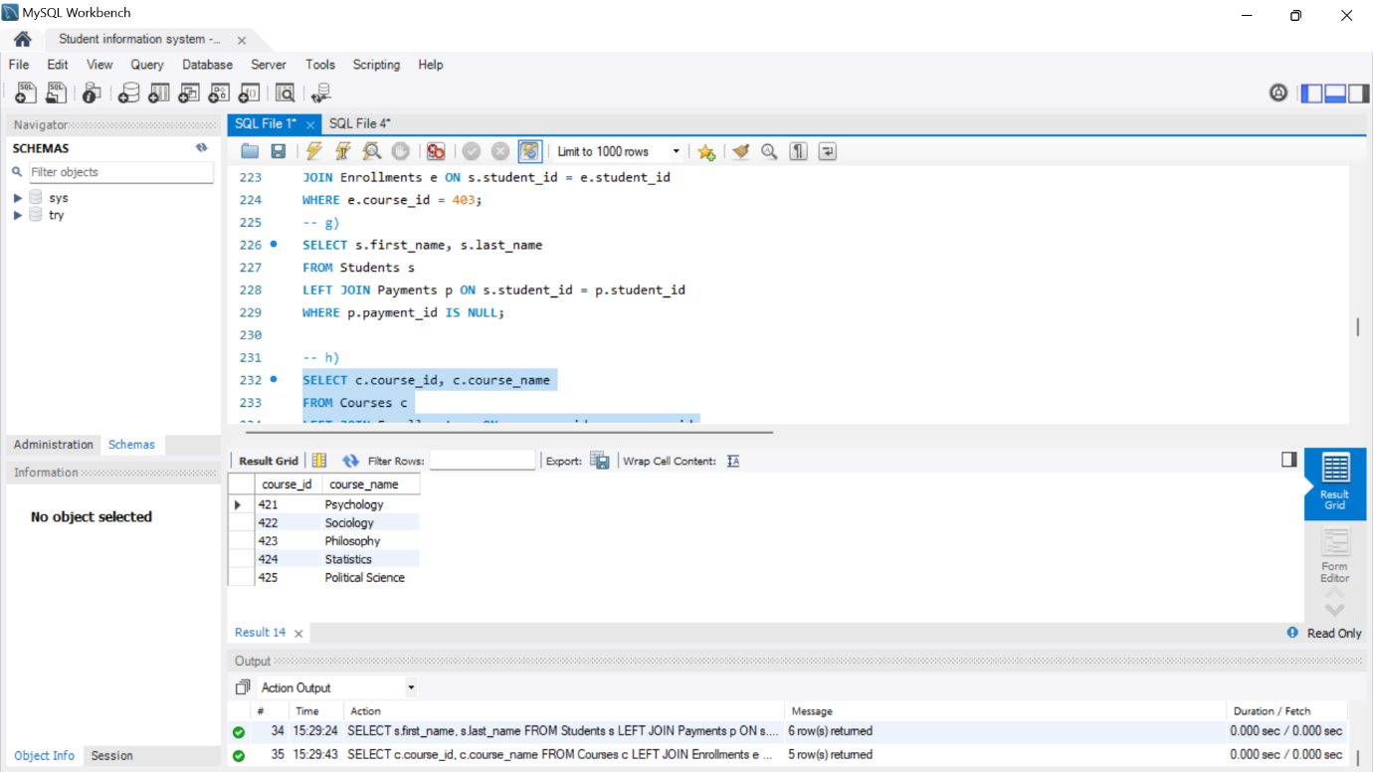

**9. Identify students who are enrolled in more than one course. Use a self-join on the "Enrollments" table to find students with multiple enrollment records.**

SELECT e1.student_id, COUNT(DISTINCT e1.course_id) AS courses_enrolled

FROM Enrollments e1

JOIN Enrollments e2 ON e1.student_id = e2.student_id AND e1.enrollment_id <> e2.enrollment_id

GROUP BY e1.student_id

HAVING COUNT(DISTINCT e1.course_id) > 1;

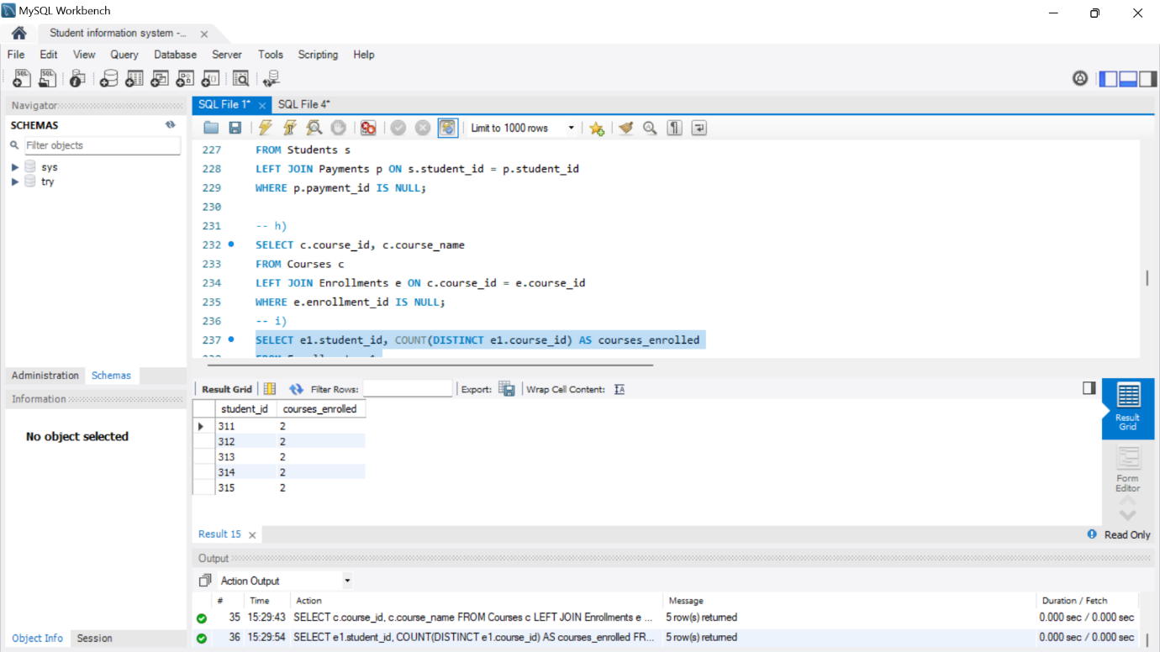

**10. Find teachers who are not assigned to any courses. Use a LEFT JOIN between the "Teacher" table and the "Courses" table and filter for teachers with NULL course assignments**

SELECT t.first_name, t.last_name

FROM Teacher t

LEFT JOIN Courses c ON t.teacher_id = c.teacher_id

WHERE c.course_id IS NULL;

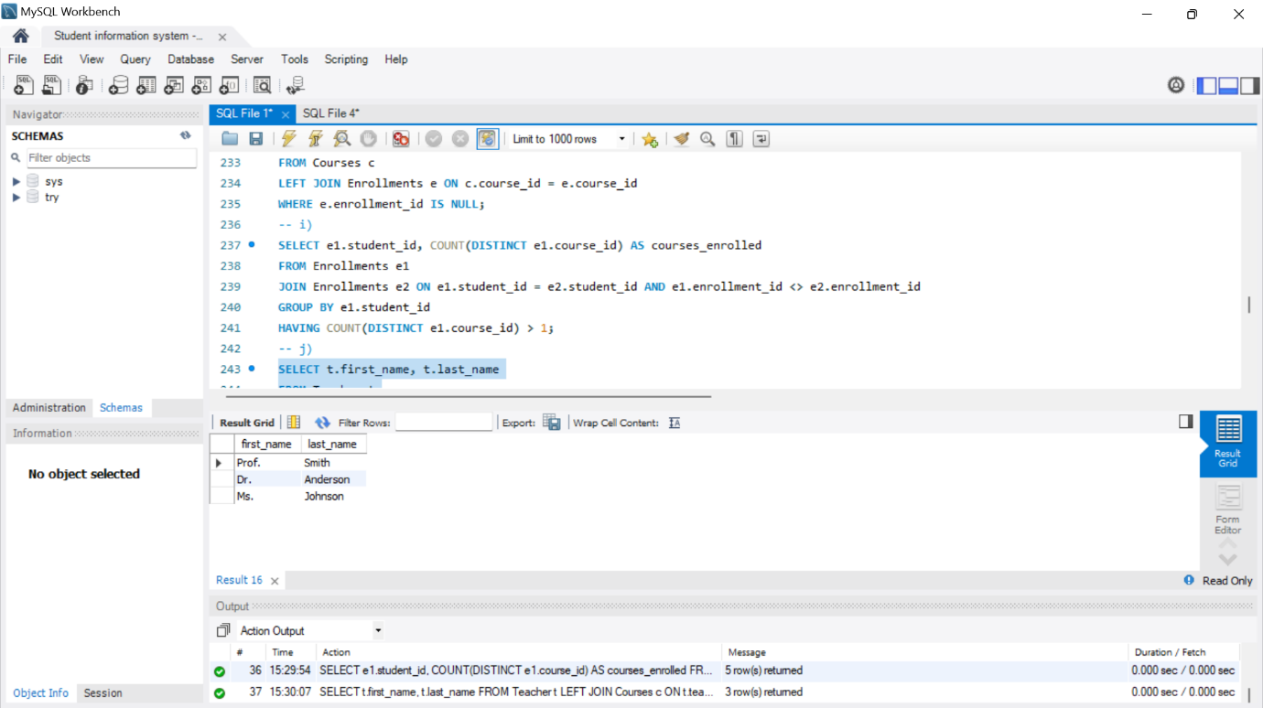

**TASK5-**

**-- 1 Write an SQL query to calculate the average number of students enrolled in each course.**

**-- Use aggregate functions and subqueries to achieve this.**

select c.course_id, c.course_name, avg(e.student_id) as average_students_enrolled

from Courses c left join Enrollments e on c.course_id = e.course_id group by c.course_id, c.course_name;

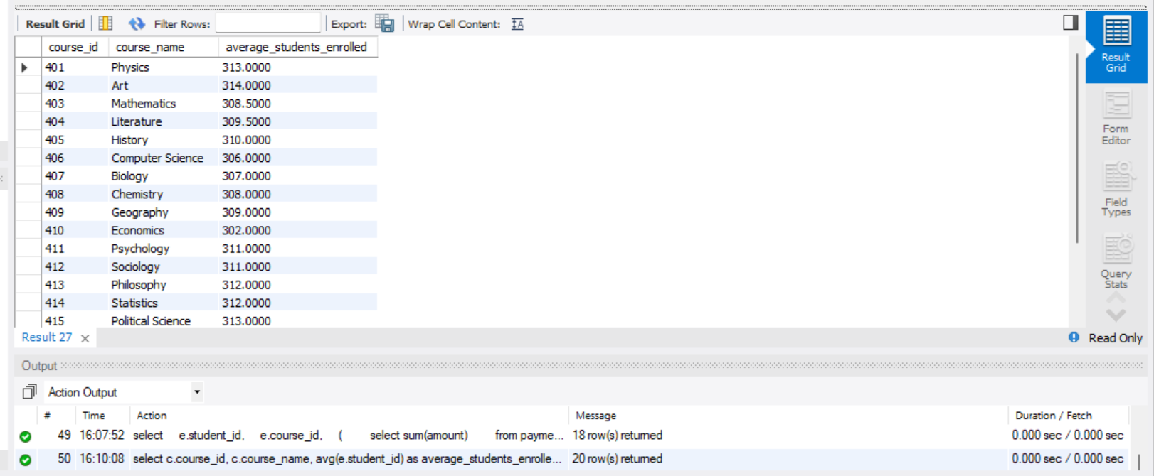

**-- 2 Identify the student(s) who made the highest payment. Use a subquery to find the maximum payment amount**

**-- and then retrieve the student(s) associated with that amount.**

select amount, payment_date,student_id from Payments where amount = (select max(amount) from Payments);

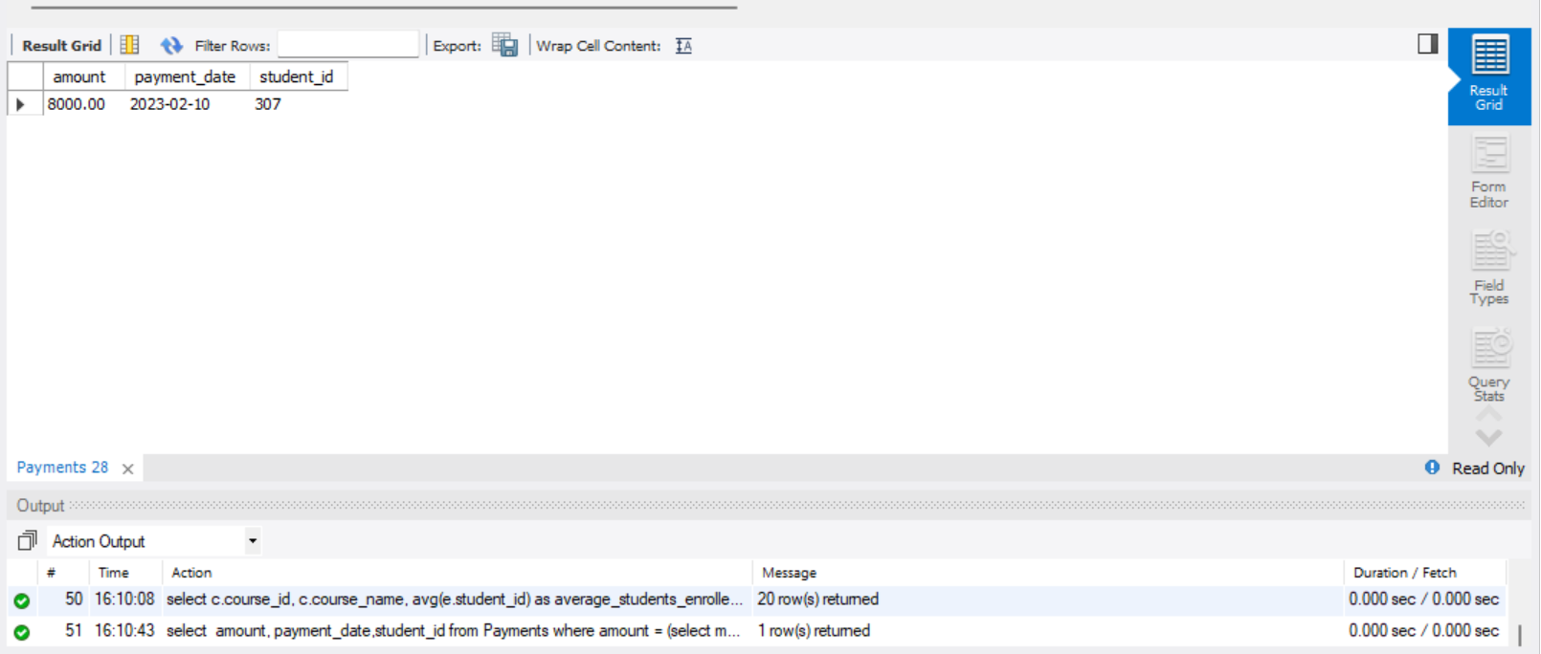

**-- 3 Retrieve a list of courses with the highest number of enrollments.**

**-- Use subqueries to find the course(s) with the maximum enrollment count.**

select c.course_id, c.course_name, count(e.enrollment_id) as en_count

from Courses c left join Enrollments e on c.course_id = e.course_id group by c.course_id, c.course_name having en_count = (select max(en_count) from (select count(enrollment_id) as en_count from Enrollments group by course_id) as maximum_enrolls);

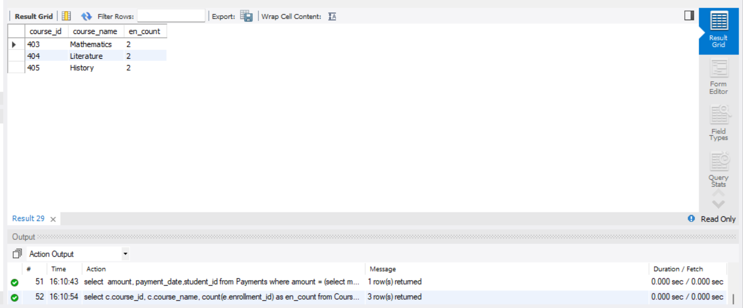

**/* 4. Calculate the total payments made to courses taught by each teacher. Use subqueries to sum**

**payments for each teacher's courses. */**

select c.teacher_id,(select sum(amount) from payments p join enrollments e on p.student_id = e.student_id where e.course_id = c.course_id) as total_payments from courses c;

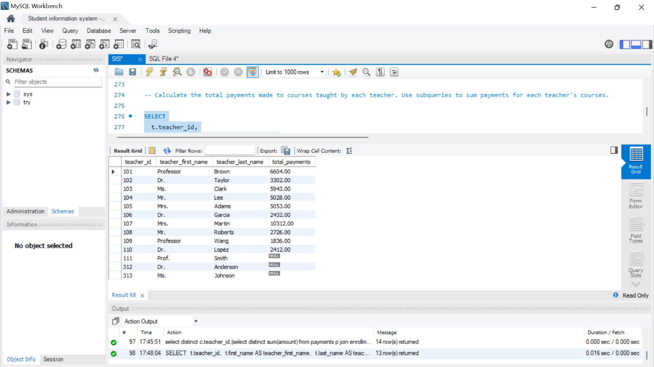

**/* 5. Identify students who are enrolled in all available courses. Use subqueries to compare a**

**student's enrollments with the total number of courses. */**

select student_id from Enrollments group by student_id having count(distinct course_id) = (select count(distinct course_id) from Courses);

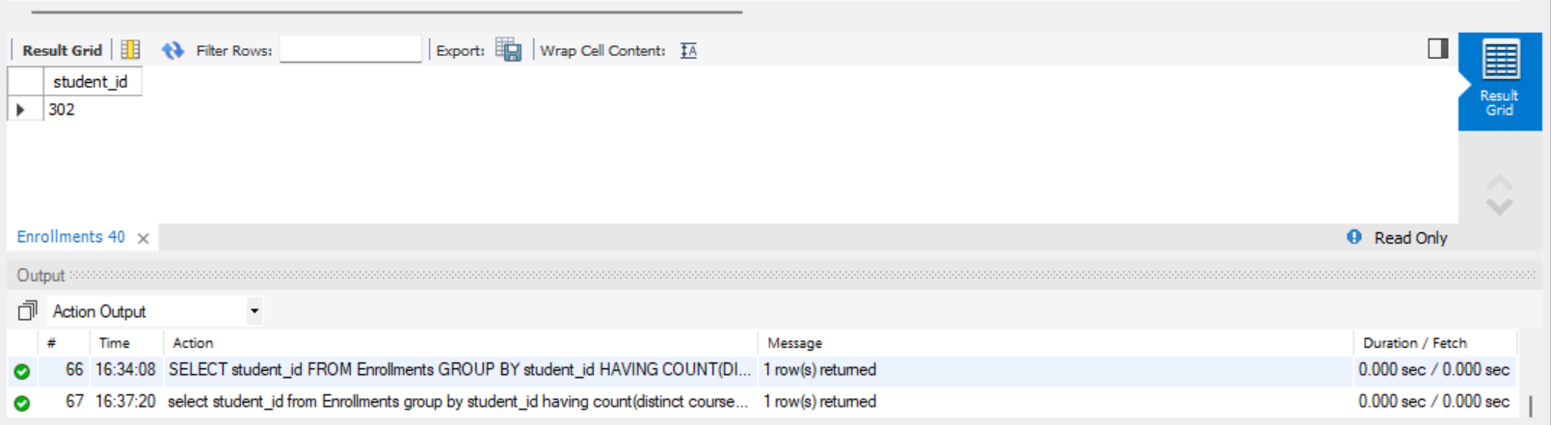

**/* 6. Retrieve the names of teachers who have not been assigned to any courses. Use subqueries to find teachers with no course assignments. */**

select teacher_id, first_name, last_name from Teacher where teacher_id not in (select distinct teacher_id from Courses);

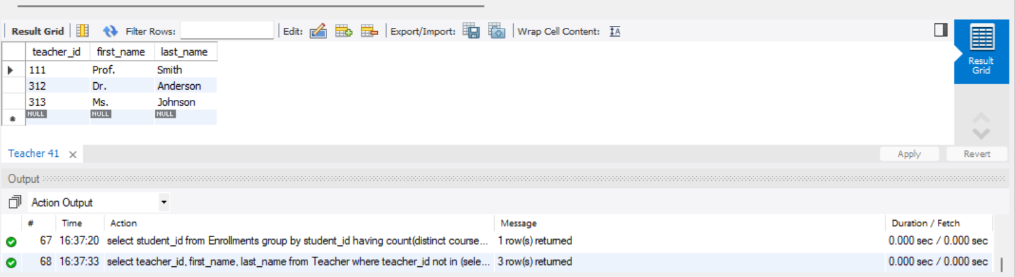

**/* 7. Calculate the average age of all students. Use subqueries to calculate the age of each student**

**based on their date of birth. */**

select avg(student_age) as average_age

from (select datediff(curdate(), date_of_birth) / 365 as student_age from Students) as avg_ages;

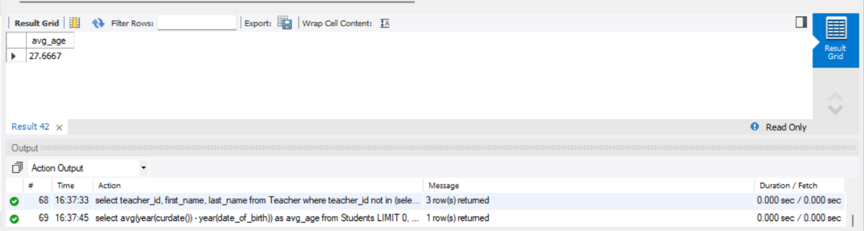

**/* 8. Identify courses with no enrollments. Use subqueries to find courses without enrollment**

**records. */**

select course_id, course_name from Courses where course_id not in (select distinct course_id from Enrollments);

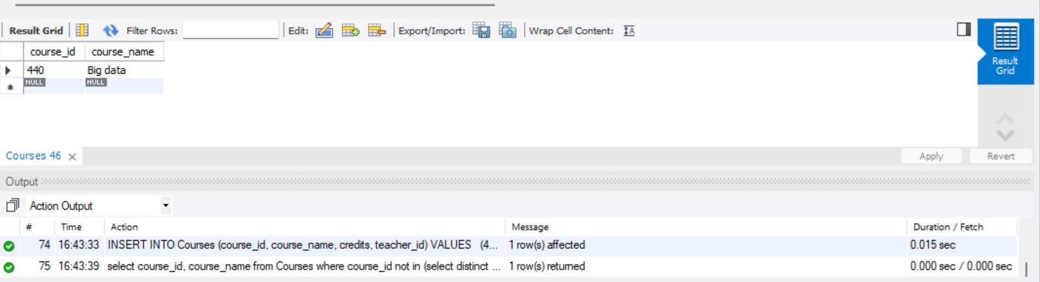

**-- 9. Calculate the total payments made by each student for each course they are enrolled in. Use**

**-- subqueries and aggregate functions to sum payments.**

select e.student_id,e.course_id,(select sum(amount) from payments p where p.student_id = e.student_id) as total_payments from enrollments e;

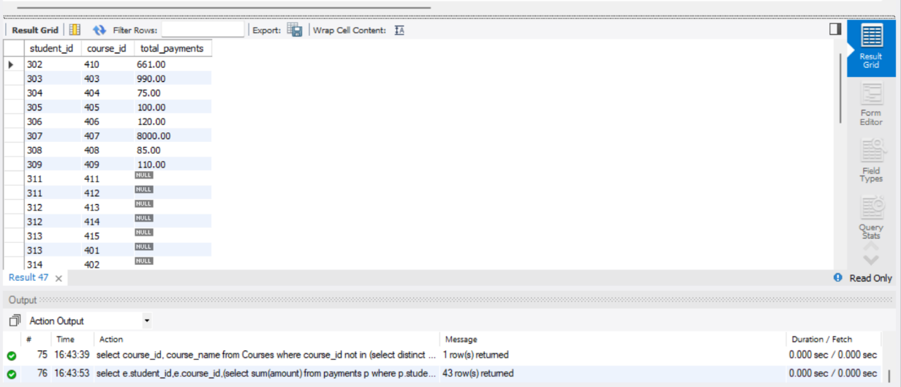

**-- 10. Identify students who have made more than one payment. Use subqueries and aggregate**

**-- functions to count payments per student and filter for those with counts greater than one.**

select s.student_id, s.first_name, s.last_name from students s

join ( select student_id, count(payment_id) as payment_count from payments group by student_id)

as payment_counts on s.student_id = payment_counts.student_id

where payment_counts.payment_count > 1;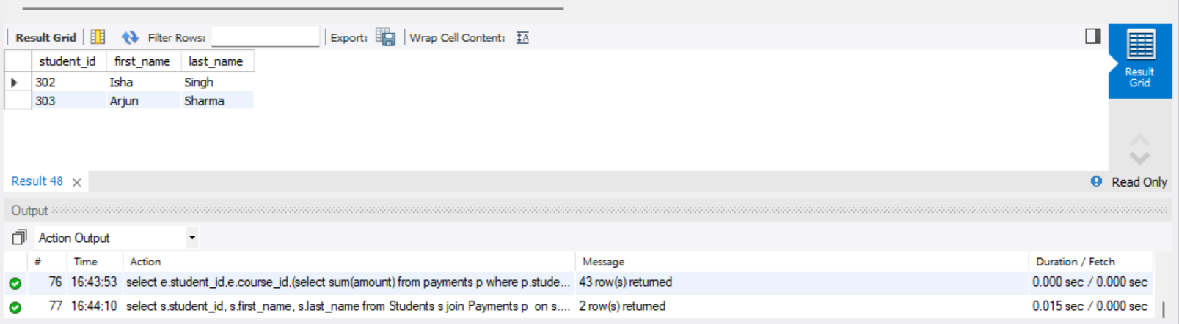

**-- 11. Write an SQL query to calculate the total payments made by each student. Join the "Students"**

**-- table with the "Payments" table and use GROUP BY to calculate the sum of payments for each**

**-- student.**

select s.student_id, s.first_name, s.last_name, sum(p.amount) as total_payments from Students s

join Payments p on s.student_id = p.student_id group by s.student_id;

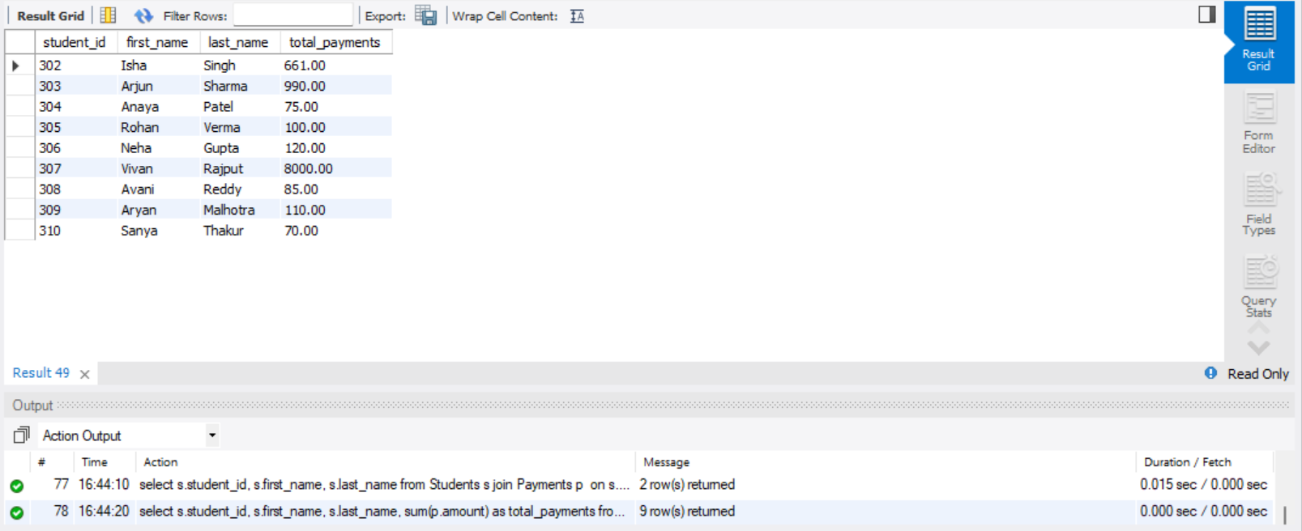

**-- 12. Retrieve a list of course names along with the count of students enrolled in each course. Use**

**-- JOIN operations between the "Courses" table and the "Enrollments" table and GROUP BY to**

**-- count enrollments.**

select c.course_name, count(e.enrollment_id) as students_enrolled from Courses c

left join Enrollments e on c.course_id = e.course_id group by c.course_id;

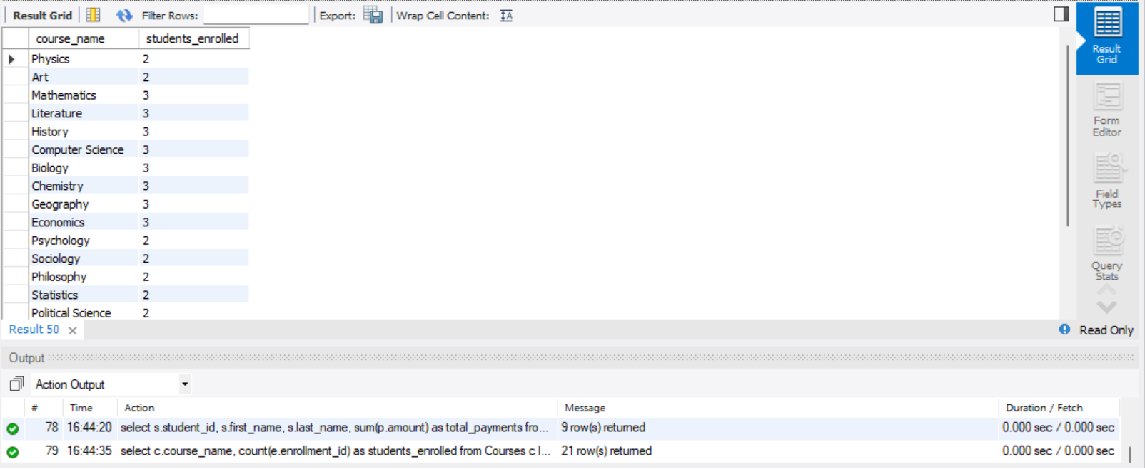

**-- 13. Calculate the average payment amount made by students. Use JOIN operations between the**

**-- "Students" table and the "Payments" table and GROUP BY to calculate the average.**

select s.student_id, s.first_name, s.last_name, avg(p.amount) as average_payment_amount from Students s join Payments p on s.student_id = p.student_id group by s.student_id;

